Voki Avatar 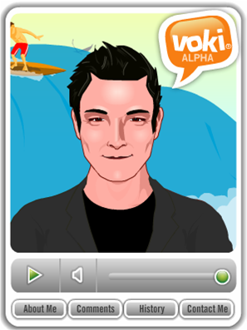
https://www.voki.com/classroom/login_status.php?
Create an avatar to summarize your book.
For Fictional Books:
This avatar can represent a character from the story or a narrator.
Be sure to include all parts of the plot:
- Introduction
  - Characters
  - Setting (time, place, mood)
  - Conflict
- Rising Action
- Climax
- Falling Action
- Resolution
For Nonfiction Books:
This avatar should tell important information about the subject of the book. Give an good overview of facts that you learned from reading this book.
The avatar could represent you, the author, or a character from the book. It could also be someone associated with the topic of the book, for example a zookeeper or scientist.

